ADD User
Server Login: Administrator  Password: Pakistan123  Static IP:192.168.1.1  DNS:192.168.1.1 | Windows10 User: Adbul  Password: Pakistan123  Static IP:192.168.1.2  DNS:192.168.1.1

In this activity, I Configured Windows Server 2022 and deployed a new Active Directory forest with the domain name Calgary.com.
Part 1: IP Configuration
Step1: Join your Windows 10 device to the Calgary.com server domain
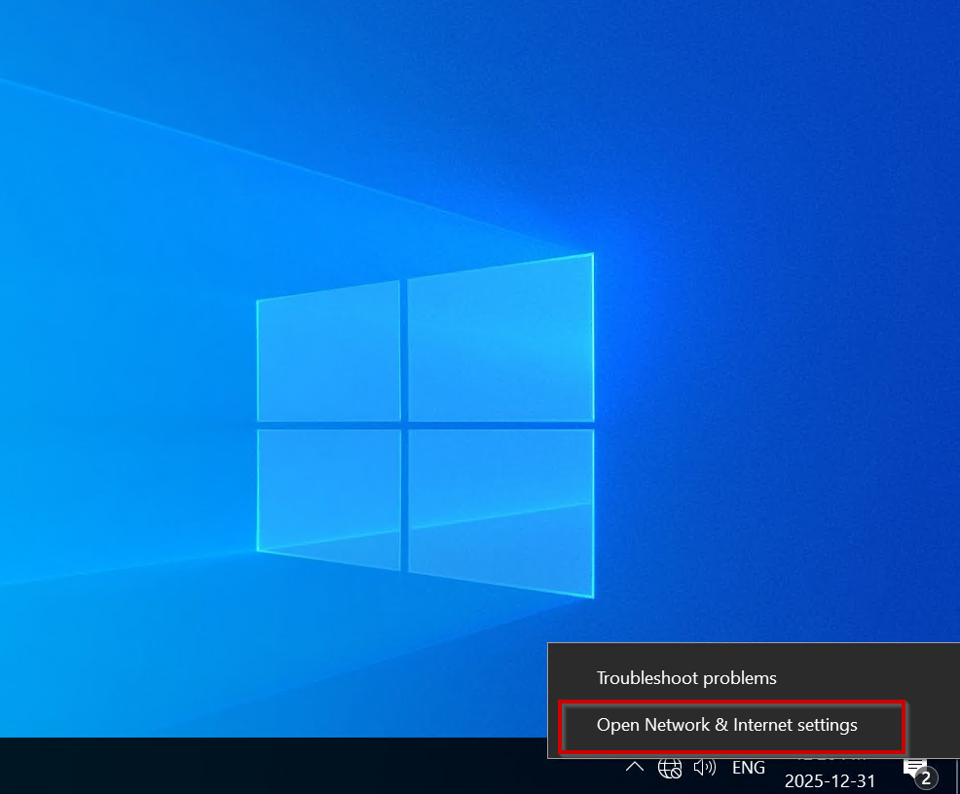

Step2: Network Setting
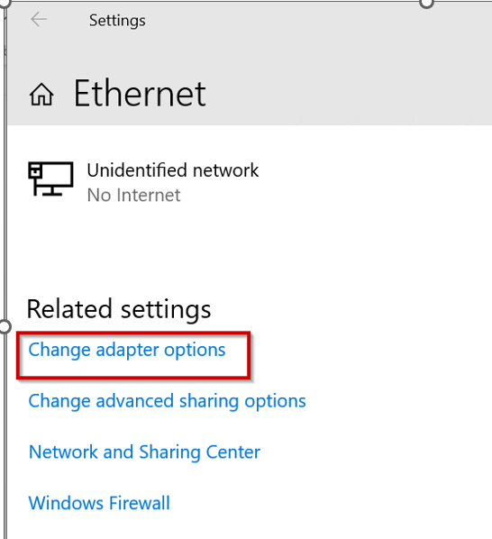
Step3: Ethernet Properties
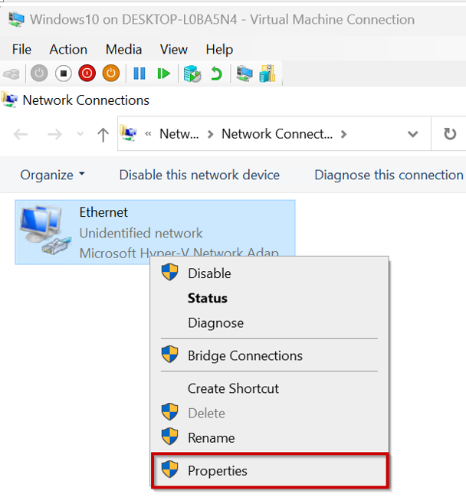
Step4:IPV4
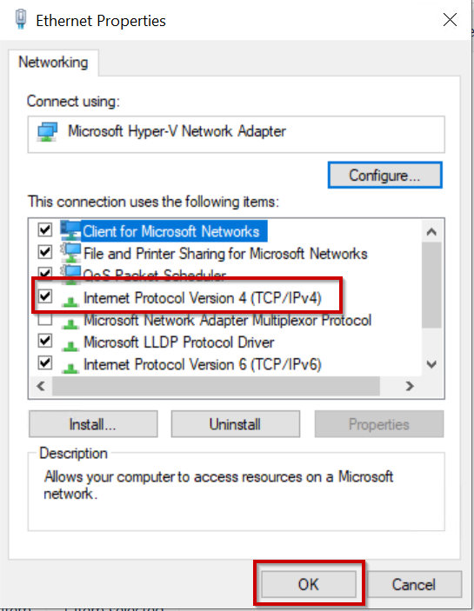
Step 5: A static IPv4 address (192.168.1.2) was configured on the Windows 10 machine with a subnet mask of 255.255.255.0 (Class C). The preferred DNS server was set to 192.168.1.1, corresponding to the Windows Server 2022 static IP.
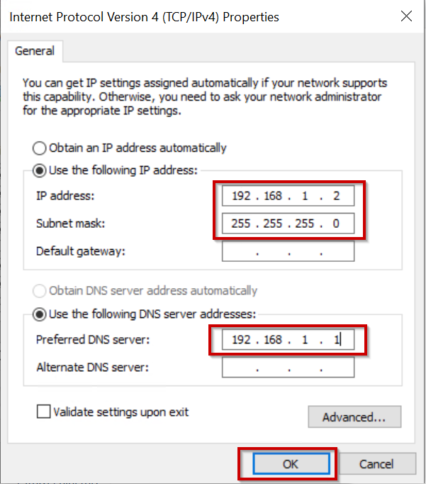

Part 2: Join Domain “Calgary.com”
Step1: From task manager go to System Properties
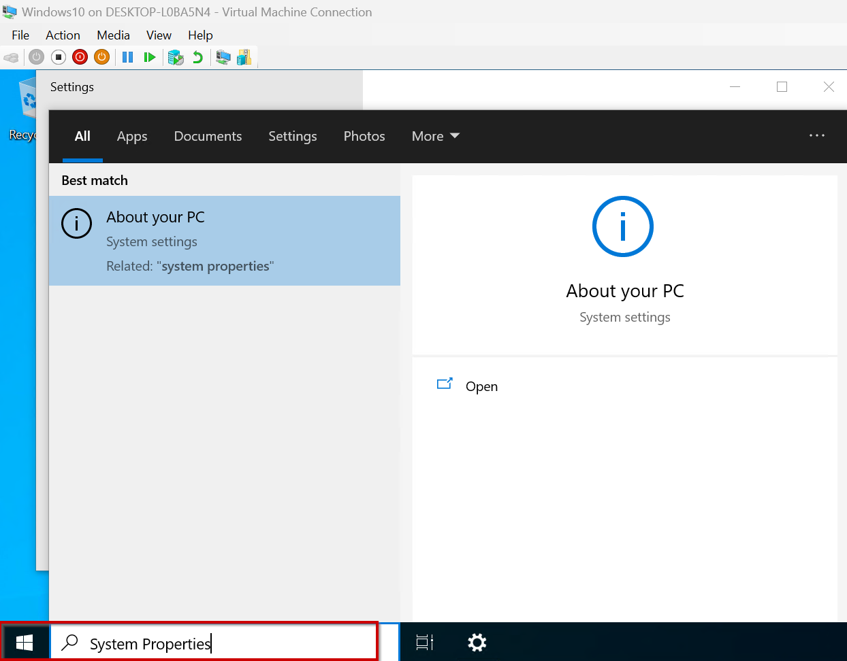
Step 2: Advanced System setting
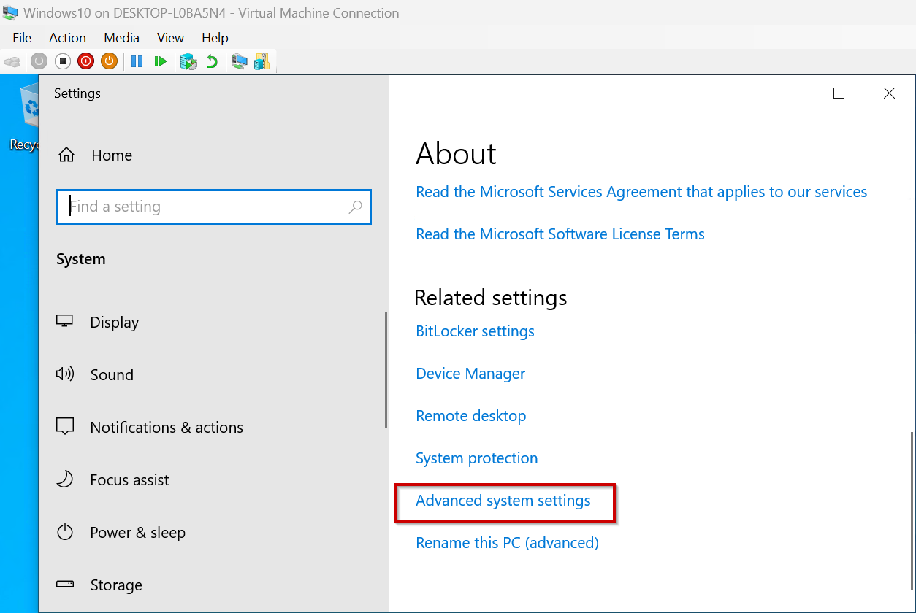
Step 3: System properties
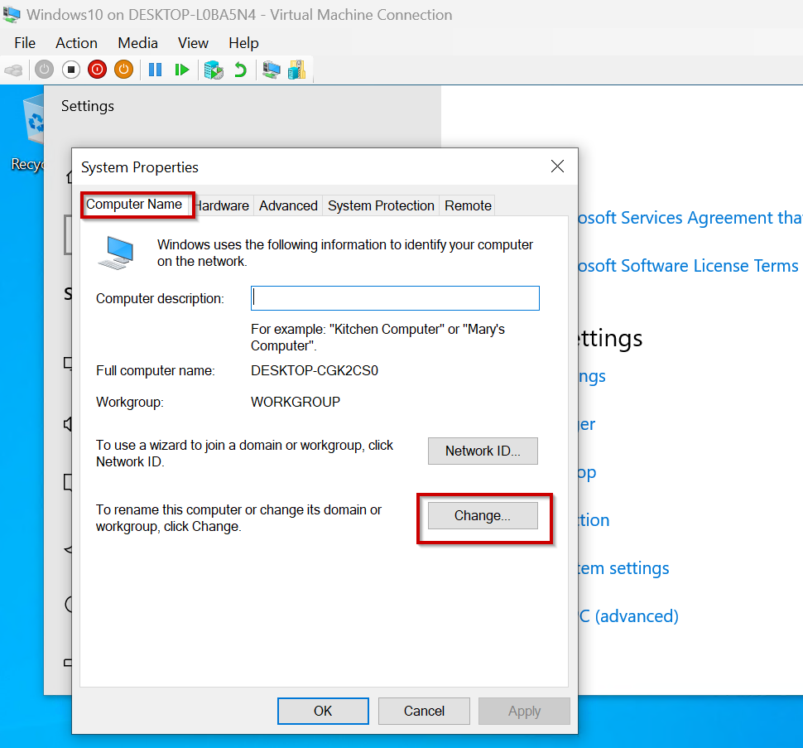

Step4: The system was originally part of a workgroup. I joined it to the Calgary domain and renamed the computer to PC.
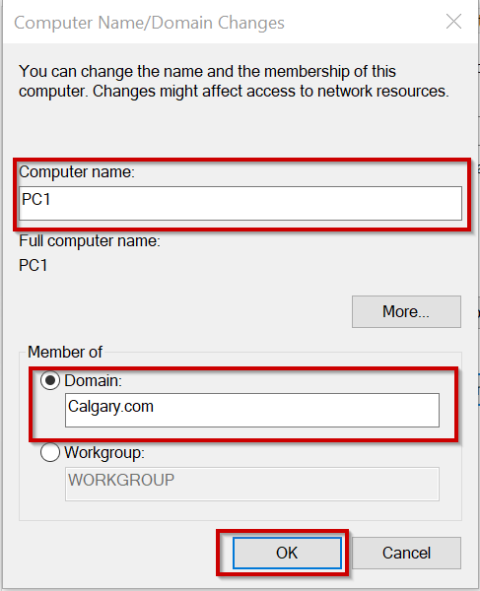
Step5: Server Name & Password
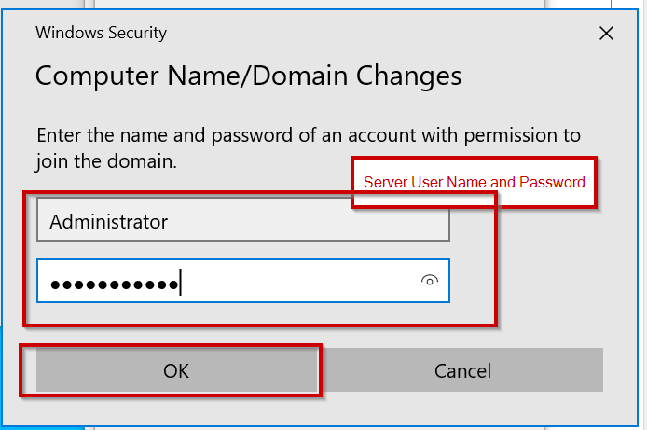

Step 6: The computer successfully joined the domain.”
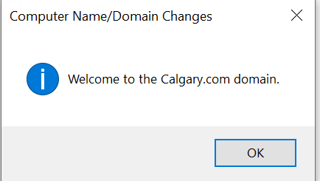
Step7: Restart Computer
Part 3: Add Active Directory Users
Step 1: From the server, access Active Directory Users and Computers via the Tools option.
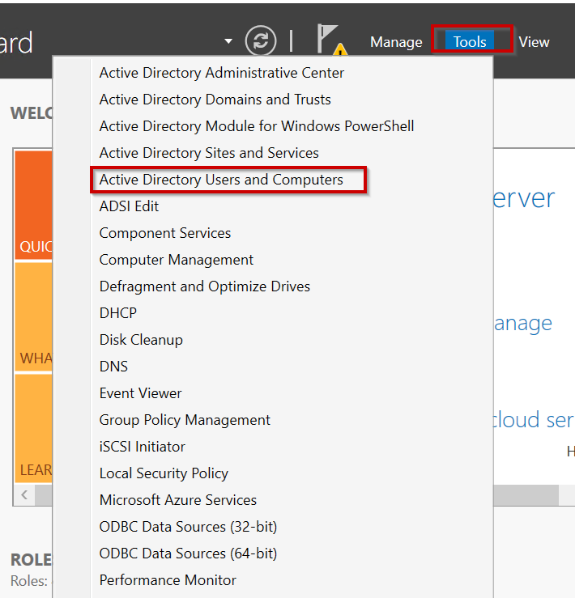

Step2: Add New User
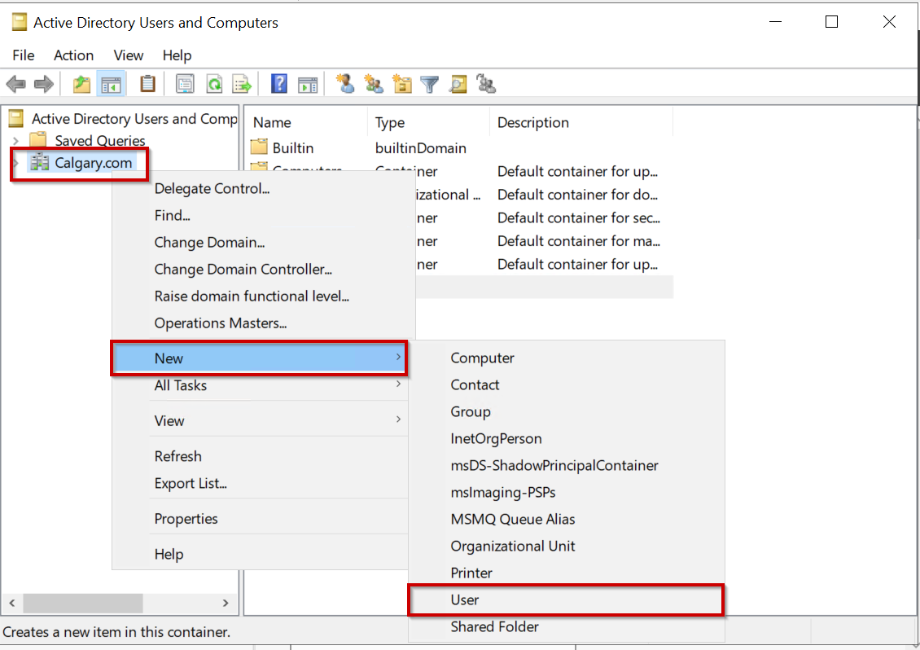Step 3: Added a new user account named Student 3 to the domain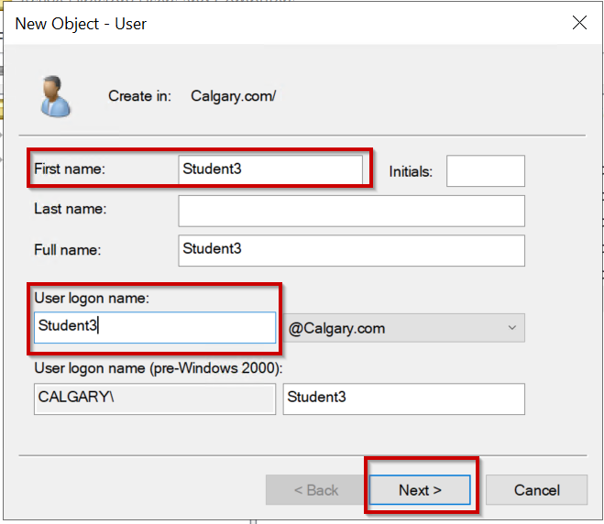
Step4: Set Password
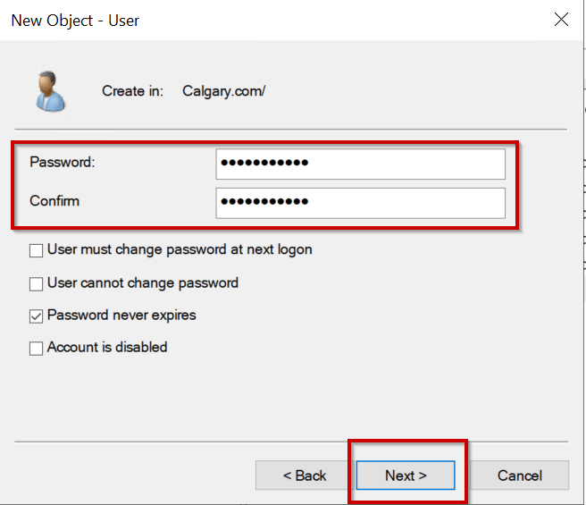
Step5: Finish
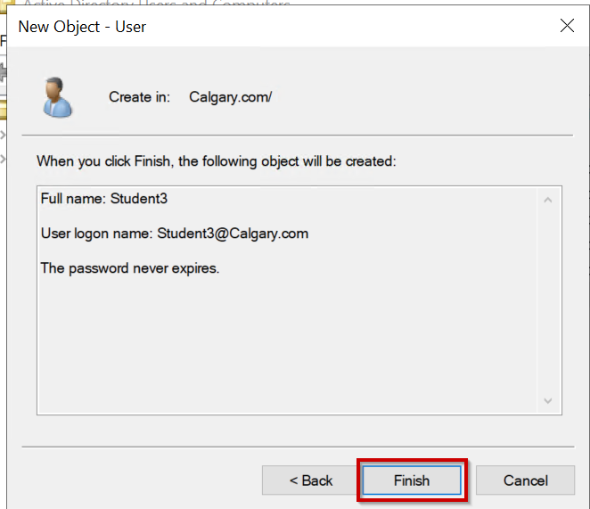
Part 4: Remote Desktop
Next, remotely log in to the Windows 10 machine as Student 3
Step 1: Open Task Manager and navigate to the Remote Desktop settings.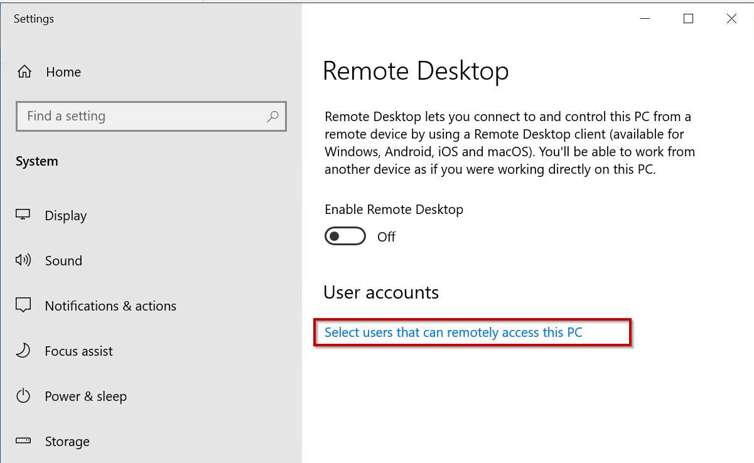
Step2: Add User
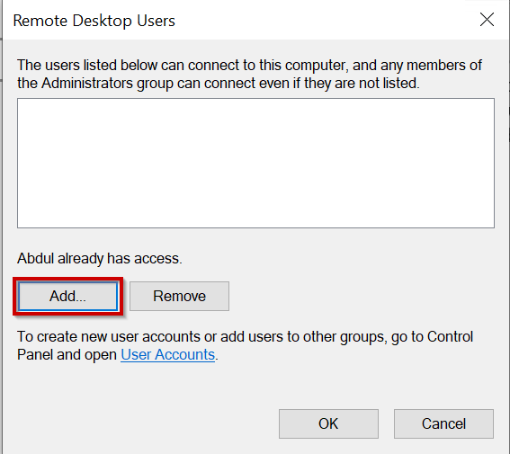
Steudent3
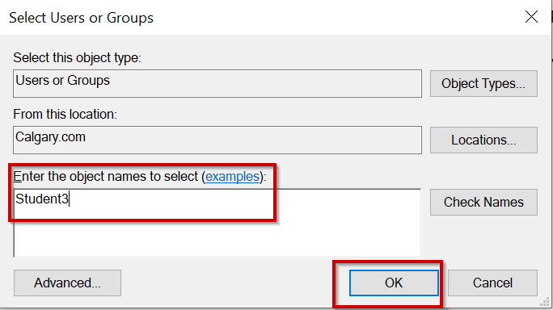
Step4: Authentication
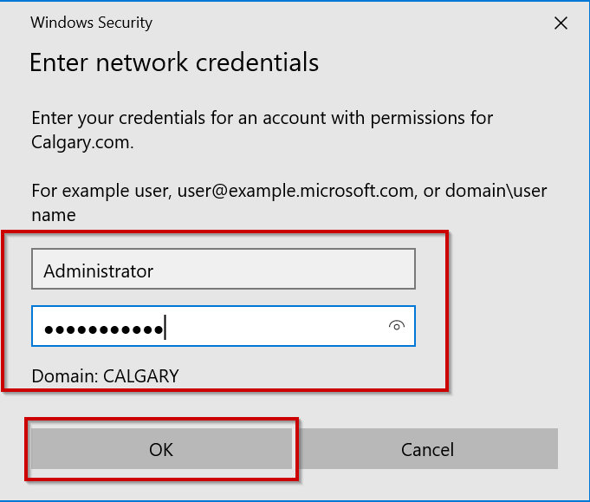
PC Name Abdul has access to student3
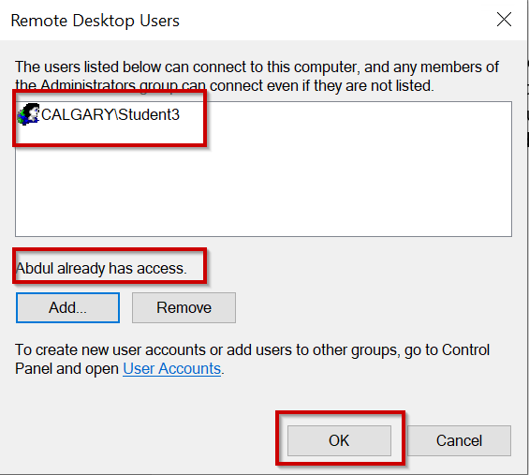
Last Step: Login Student3
